Date: 16-10-2025

INTERNSHIP LETTER

This is to certify that Mr. Neelesh kumar Yadav was working in our organization
Ozrit Ai Solutions as “Digital Marketing Intern” from 08.07.2025 to 08.10.2025

We hereby certify that his performance was good during the tenure.
His contribution to the organization and its success will always be appreciated.
We wish him all the best in his future endeavors.

For Ozrit Ai Solutions.

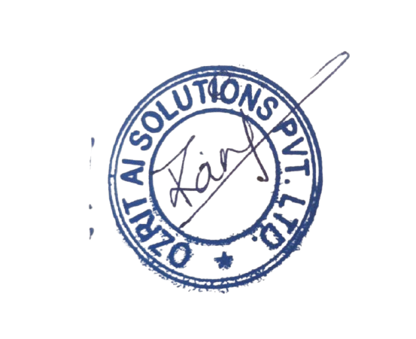
Rani Kumari
HR & Admin Executive

